【无机化学论坛】Molecular Spin Qubits for Quantum Computer and High-Density Memory Devices Based on Molecular Magnets

报告人: Prof. Masahiro Yamashita
Department of Chemistry, Faculty of Science, Tohoku University

时间：2024年4月2日（周二） 上午10:00-11:30
地点：北京大学化学学院肖伦报告厅C区101大教室.

报告摘要
Spintronics, based on the freedoms of charge and spin of the electron, is a key technology in the 21st century. Magnetic random access memory (MRAM), which uses giant magnetoresistance (GMR), has several advantages compared with electronics. Although conventional magnets composed of transition metals are normally used, in our study, we use molecule-based nano-magnets and single-molecule magnets (SMMs) to overcome “Moore`s Limitation”. SMMs are also available for quantum computer. I will talk about the molecular spin qubits for quantum computer ([1]Crystal Engineering Method, [2]g-Tensor Engineering Method, [3]Orbital Engineering Method, and [4]Molecular Technology Method) as well as high-density memory devices such as single-molecule memory device, SMMs encapsulated into SWCNT, and metallic conducting SMMs with negative magnetoresistances.

报告人简介：

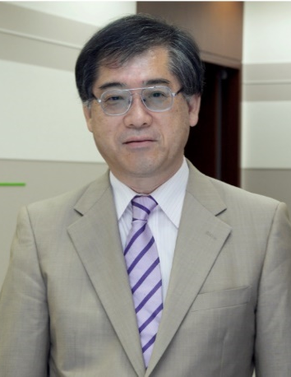
Emeritus Professor Masahiro Yamashita, FRSC

Birthday: 12th September, 1954
Nationality: Japanese
Affiliation: Department of Chemistry, Graduate School of Science,
Tohoku University, Japan
Address: 6-3 Aramaki-Aza-Aoba, Aoba-Ku, Sendai, 980-8578, Japan
Phone: +81-22-795-6544 Fax: +81-22-795-6548
E-mail: masahiro.yamashita.c5@tohoku.ac.jp
URL: https://yamashita-group.wixsite.com/yamashita-group

Education/Careers;
- Kyushu University (PhD)
1982 JSPS Post Doctor of Institute for Molecular Science
1983 Assistant Professor of Kyushu University
1987 Associate Professor of Nagoya University
1989-1990 Visiting Professor of University College London (UK)
1998 Professor of Nagoya University
1999 Professor of Tokyo Metropolitan University
2004- Professor of Tohoku University
2016 Lecture Professor of Nankai University (China)
2020- Emeritus Professor of Tohoku University
2022- Adjunct Professor of IISER Bhopal (India)
2023- Changjiang Chair Professor of Tongji University (China)

Awards & Distinctions:
- Inoue Scientific Award
- The Chemical Society of Japan Award for Creative Work for 2005
- Best Paper Award in J. Phys. Soc. Jpn.
2009 Associate Member of Science Council of Japan
2011 Award for International Conference Attraction (JNTO)
2013 Fellow of Royal Society of Chemistry (FRSC)
2014 Award of Japan Society of Coordination Chemistry
2019 Mukai Award
2019 Honorable Doctorate from University of Ss. Cyril and Methodius (Slovakia)
2019 The Chemical Society of Japan Award for 2019
2023 MOE Changjiang Chair Professorship

Publications:
Original Paper: 526, Reviews: 108, Books: 21 Total:655

